Bergen County Brain Injury
Social Gatherings
www.brain411.org

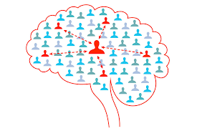

Overview

Social opportunity to interact and share with others
Held at multiple locations where attendees can purchase food and drink of their choice

This is Not a Support Group Meeting – No Facilitator will be Present

Support Group Meetings will continue to be held
on the 3rd Monday of Every Month

2020 – Locations

See Gathering Locations on other side

2020 – Schedule

6:00 PM - ???
1st Monday of Every Month

Jan 6 | Feb 3 | Mar 2
Apr 6 | May 4 | Jun 1
Jul 6 | Aug 3 | Sep
Oct 5 | Nov 2 | Dec

Contact

Joe and Jane Concato
jjconc@optonline.net
201-666-2015 (Home)
Locations

Gatherings on the same day
(1st Monday of each month)
at multiple locations throughout Bergen County

For those who choose to attend
you can select the nearest location

Location 1
Panera Bread
95 Route 17 South
East Rutherford, NJ 07073
​
Location 2
Panera Bread
10 Sterling Blvd
Englewood, NJ 07631
​
Location 3
Panera Bread
770 Route 17 North
(Not in Paramus Park)
Paramus, NJ 07652
​
Location 4
Panera Bread
269 Livingston St
Northvale, NJ 07647
​
Location 5
Panera Bread
Ramsey Square
1300 Route 17 North
Ramsey, NJ 07446

